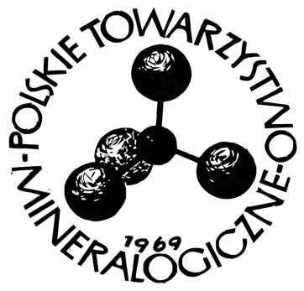

……..…………………………..
Place, date

To the Management Board of
Polskie Towarzystwo Mineralogiczne
Mineralogical Society of Poland
30-059 Kraków, al. Mickiewicza 30

APPLICATION
Name of the institution where the thesis was carried out
Student’s name and surname
Supervisor’s (and co-supervisior’s) name and surname
Title of the diploma thesis
Person submitting the application
E-mail:

I hereby express my willingness to participate in the Mineralogical Society of Poland’s Competition for the best diploma theses in the field of mineralogical sciences (mineralogy, geochemistry, petrology, applied and environmental mineralogy and geochemistry), in the category of master’s/doctoral thesis (*). I declare that I have read and accept the provisions of the Competition Regulations.

…………………………………………………..
(Signature of the person submitting the application)

