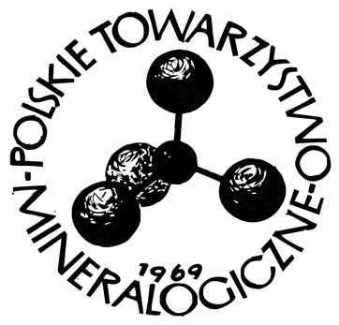

……..…………………………..
Place, date

To the Management Board of
Polskie Towarzystwo Mineralogiczne
Mineralogical Society of Poland
30-059 Kraków, al. Mickiewicza 30

DECLARATION

I hereby give my consent to the submission the diploma thesis

…………………………………………………………………………………………………(*)
carried out under my scientific supervision, to the Mineralogical Society of Poland’s Competition for the best diploma theses in the field of mineralogical sciences (mineralogy, geochemistry, petrology, applied and environmental mineralogy, and geochemistry). I declare that I have read and accept the provisions of the Competition Regulations.
I consent to the processing of my personal data for the purposes necessary to carry out the competition procedure (in accordance with the Act of 29 August 1997 on the Protection of Personal Data, Journal of Laws No. 133, item 883, as amended). I also consent to the publication of my name and surname, along with the title of the diploma thesis conducted under my supervision, on the website of the Mineralogical Society of Poland.

…………………………………………………..
(Signature of the thesis Supervisor)

(*) Please enter the student’s name and surname

