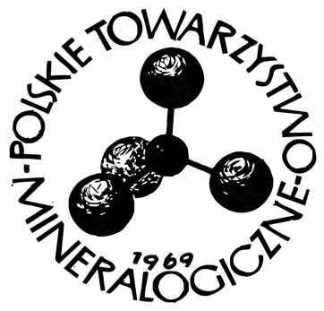

……..…………………………..
Place, date

To the Management Board of
Polskie Towarzystwo Mineralogiczne
Mineralogical Society of Poland
30-059 Kraków, al. Mickiewicza 30

CONSENT

I hereby consent to the processing of my personal data for the purposes necessary to carry out the competition procedure related to my application to the Mineralogical Society of Poland’s Competition for the best diploma theses in the field of mineralogical sciences (mineralogy, geochemistry, petrology, applied and environmental mineralogy and geochemistry) (in accordance with the Act of August 29, 1997 on the Protection of Personal Data, Journal of Laws No. 133, item 883, as amended). I also consent to the publication of my full name and the title of my diploma thesis, as well as a brief informational note in the form of a popular science description of the thesis and a graphic illustration on the website of the Mineralogical Society of Poland.

…………………………………………………..
(Student’s signature)

